Declare a variable name ‘x’ and value ‘Hello world’, print it

Workshop #2

Flutter Developer Bootcamp

# **Purpose**

This workshop demonstrates likely to introduce participants to the Dart programming language, focusing on its syntax, basic operations, and running simple programs.

**Problem**

In the given workshop demonstrates a simple program where the main function serves as the entry point. Within main, a variable x is declared and initialized with the string 'Hello world' using the var keyword. The print function then outputs the value of x to the console. This example introduces basic Dart concepts such as function definition, variable declaration, and console output, providing a foundation for beginners to learn Dart programming.

**How to Solve**

1. Checkout the workshop from Git Repo:

git clone -b <user-branch> <repo-URL>

1. Open the root folder inside VS Code
2. Open the root folder in terminal
3. Run the command dart run filename.dart
4. Variable Declaration: Uses var for type inference (var x = 'Hello world';).
5. String Handling: Assigns 'Hello world' to variable x.
6. Console Output: Uses print(x); to display 'Hello world' to the console.
7. Go To File: <specific-file--method> à <method-name>, implement your logic.

**You will Achieve**

When you complete this workshop you will learn the following:

Methods and Functions Included**:**

* **main Function:**
* void main(List<String> args)
* Entry point of the Dart program where execution starts. Can accept command-line arguments (args) if provided.
* **print Function:**
* print('Hello world');
* Outputs the specified message or variable content to the console.

# **Screenshots**

## **Before implementation (without printing hello world)**

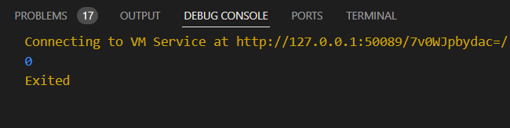

## **After implementation ( declare a variable x and printing hello world)**

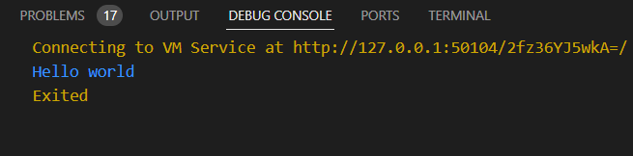

# **How to submit your workshop**

Push your project back to the same git branch using command:

<command name>

# **Happy Coding!**